**CGPSS 2016 / ECEMD 2016**

List of changes (relative to 2013 instrument)

**Modifications**

1. THESIS –
2. Section 1. Educational Status
3. Section 4. Professional Skills Development
4. Section 6. Presentations and Publications
5. Section 7. Advisor and Thesis/Dissertation/Research Paper
6. Section 8. Financial Support
7. Section 9. University Resources and Student Life
8. Section 10. Social Life
9. Section 11. General Assessment
10. Section 12. Personal Demographics

**Rationale for changes**

1. Small wording change to recognize that students in mostly course-based program still have some level of supervision
2. Add question on primary reason for attending this graduate program
3. Add item on Job Hunting
4. Small wording change to the french version, to make it simpler and more similar to the english version
5. Add item on discussing career prospects and questions on Advisory Committees – measure pervasiveness and satisfaction
6. Add a choice option to recognize and important funding mechanism, especially in Quebec
7. Add item on Disability/Access Services Office – see also below
8. Add question on actual presence on campus – Ackowledge that some graduate students seldom or never come on campus
9. Add question on importance of networking opportunities
10. Add questions to identify students with disability – measure prevalence and satisfaction with accommodation efforts

**THESIS**

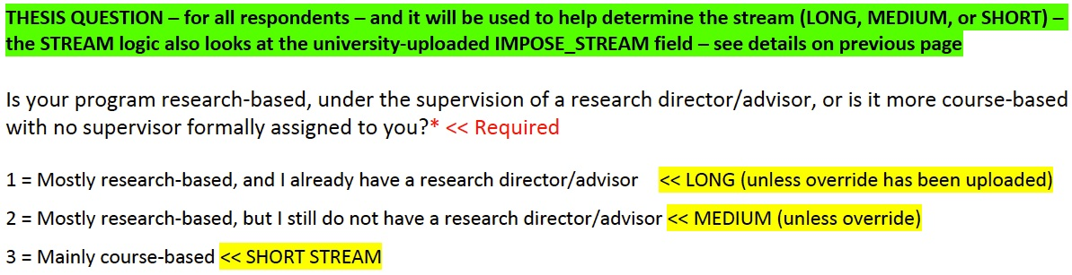

Modifications :

Small wording change to better explain the « mainly course-based » option.

Add additional examples to better explain this option.

**Is your program research‐based, under the supervision of a research director/advisor, or is it more course‐based (without the same level of supervision)?**

**3 = Mainly course-based (May include an essay or internship)**

**Section 1. Educational Status**

Modifications :

Please insert just before current question 5 – Do you expect to graduate by the end of the current acaddemic year ?

What was your **primary reason** for enrolling in your program ? **[Prim_reason]**

         To equip me to start a career, or advance an existing **career in academia [1]**

         To equip me to start a career, or advance an existing **career outside of academia [2]**

To satisfy my interest in the field, **regardless of career prospects [3]**

         Other (specify): **[Prim_reason_TXT]**

**Section 4. Professional Skills Development**

Modifications :

Add an item for all steams :

Advice/workshops on job searching (CV preparation, Interview skills, etc…) **[ProfSkill_JobHunt]**

**Section 6. Presentations and Publications**

Modifications :

Wording modification to the french version only

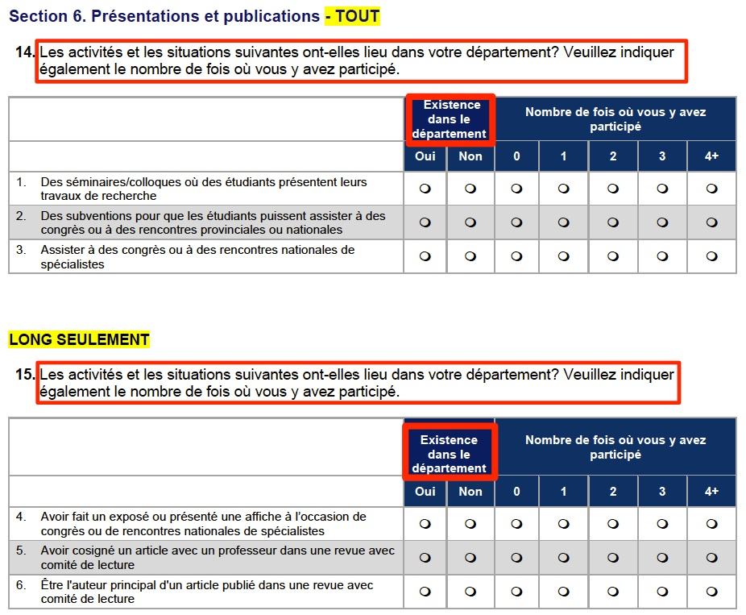

Indiquez si les activités et les situations suivantes ont lieu dans votre département, et le nombre de fois où vous y avez participé.

Occurrence

OUI / NON

**Section 7. Advisor and Thesis/Dissertation/Research Paper**

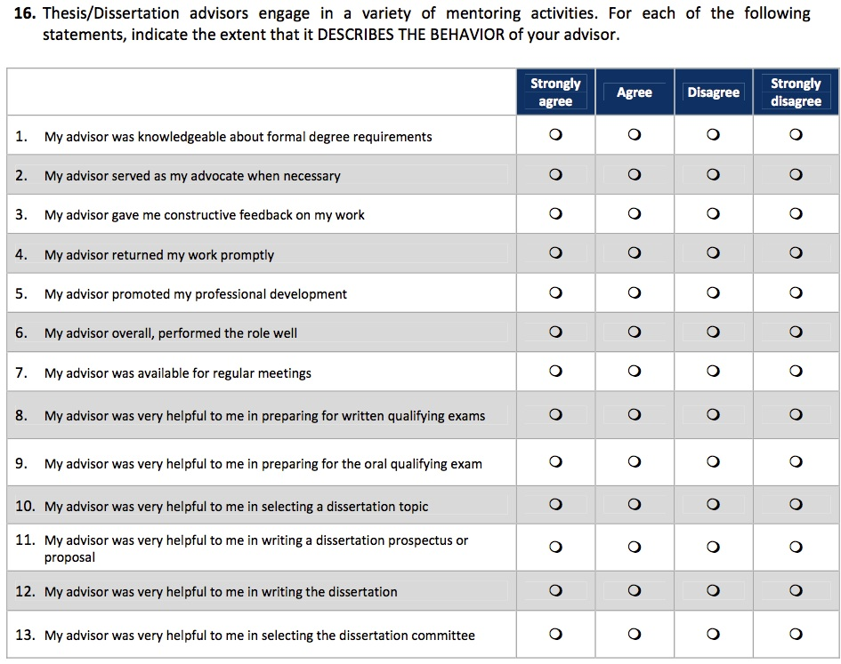

Modifications

Add new item

My advisor encouraged discussions about current job market and various career prospects [Advisor_JobMarkt]

Add a new question on Advisory Committee, at the end of this section.

Do you have an advisory committee? YES = 1 / NO = 0 [AdvCmtte]

Please specify which statement(s) best describe your situation (check all that apply)

Checked = 1, UnChecked = 0

My advisory committee expects to receive from me a written progress report, at least once a year. [AdvCmtte_ProgRep]

I am expected to meet at least annually with my advisory committee. [AdvCmtte_AnnMeet]

I have already interacted at least once with my advisory committee. [AdvCmtte_Met]

How have you interacted with your advisory committee ? [AdvCmtte_Interact]

In a formal meeting

Trough email or telephone contact (no formal meeting)

Up to now, I have found my advisory committee’s feedback constructive and useful. [AdvCmtte_Useful] **Strongly agree / Agree / Disagree / Strongly disagree**

**Section 8. Financial Support**

Modifications :

Add new choice : **Provincial Bursary (need based, non-refundable)** [FinSup_ProvBursary ]

Re order the list :

|  |
| --- |
| **FinSup_Fed** |
| **FinSup_Prov** |
| **FinSup_Foreign** |
| **FinSup_External** |
| **FinSup_ProvBursary** |
| **FinSup_UnivBursary** |
| **FinSup_UnivFellowship** |
| **FinSup_FullWaiver** |
| **FinSup_PartWaiver** |
| **FinSup_RA** |
| **FinSup_TA** |
| **FinSup_Ptresearch** |
| **FinSup_Ptteaching** |
| **FinSup_ResDonship** |
| **FinSup_OthCampusJob** |
| **FinSup_OffCampusJob** |
| **FinSup_Benefit** |
| **FinSup_LoanAssist** |

**Section 9. University Resources and Student Life**

Modifications

Add new item at the end of the current list: **Disability/Access Services Office [UnivDisabl]**

NOTE : derived variables will also be generated

**UnivDisablLOC**

**UtilUnivDisabl**

**SatisUnivDisabl**

**Section 10. Social Life**

Modifications

Add additional question at the end of Section 10 :

**In the current academic year, have you been physically present on campus (or affiliated institute) premises on a regular basis, or have you been away most of the time (out of town, out of the country, field work, distance program, working at a separate location, etc…)** [Present]

**Physically present / Away most of the time**

**Section 11. General Assessment**

Modifications

Add additional questions at the end

**As it relates to your current program, how important is to have the opportunity to...**

Not applicable / Not important / Somewhat important / Very important

* **Study abroad ? [Importance_SInt]**
* **Collaborate on research internationally ? [Importance_RInt]**
* **Network with not for profit organizations ? [Importance_Org]**
* **Network with businesses ?  [Importance_Bus]**
* **Network with local/provincial/federal government  ? [Importance_Gov]**

**To date, as it relates to your current program, have opportunities been available to...**

Not applicable / No opportunity/ Yes, to some extent / Yes, to a great extent.

* **Study abroad ? [Opport_SInt]**
* **Collaborate on research internationally ? [Opport_RInt]**
* **Work/collaborate with not for profit organizations ? [Opport_Org]**
* **Work/collaborate with businesses ? [Opport_Bus]**
* **Work/collaborate with local/provincial/federal government ?  [Opport_Gov]**

**Section 12. Personal Demographics**

Modifications

Add additional questions at the end, just before the additional comment box.

**Do you self-identify with any disability or impairment? [**DisablSelfID]

Yes / No / I prefer not to respond

**[If answered ‘yes’]**

**Please specify which one(s) (select all that apply)**

* **[Disabl_sense] Sensory (vision or hearing)**
* **[Disabl_mobil] Mobility**
* **[Disabl_learn] Learning (e.g. ADHD, dyslexia)**
* **[Disabl_mental] Mental health (e.g. depression, bipolar)**
* **[Disabl_autism] Autism spectrum (e.g. autism, asperger’s)**
* **[Disabl_chronic] Chronic (e.g., Crohn’s, Colitis, MS)**
* **[Disabl_else] A disability or impairment not listed above**
* **[Disabl_else_TXT] Please define________________________**
* **Prefer not to respond**

**How would you rate your institution’s efforts to accommodate your disability or impairment in your graduate program?** [Disabl_Rate]

Excellent/Very good/Good/Fair/Poor